# Decision Tree and Random Forest

**Topic: Decision Tree and Random Forest**

**Hints:**

1. **Business Problem**
   1. **What is the business objective?**
   2. **Are there any constraints?**
2. **Work on each feature of the dataset to create a data dictionary as displayed in the below image:**

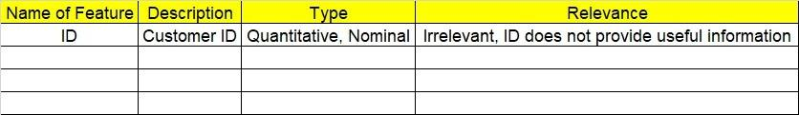

**2.1 Make a table as shown above and provide information about the features such as its data type and its relevance to the model building. And if not relevant, provide reasons and a description of the feature.**

1. **Data Pre-processing**

**3.1 Data Cleaning, Feature Engineering, etc.**

1. **Exploratory Data Analysis (EDA):**
   1. **Summary.**
   2. **Univariate analysis.**
   3. **Bivariate analysis.**
2. **Model Building**
   1. **Build the model on the scaled data (try multiple options).**
   2. **Perform Decision Tree and Random Forest on the given datasets.**
   3. **Train and Test the data and perform cross validation techniques, compare accuracies, precision and recall and explain about them.**
   4. **Briefly explain the model output in the documentation.**

1. **Write about the benefits/impact of the solution - in what way does the business (client) benefit from the solution provided?**

**Problem Statements:**

1. A cloth manufacturing company is interested to know about the different attributes contributing to high sales. Build a decision tree & random forest model with Sales as target variable (first convert it into categorical variable).

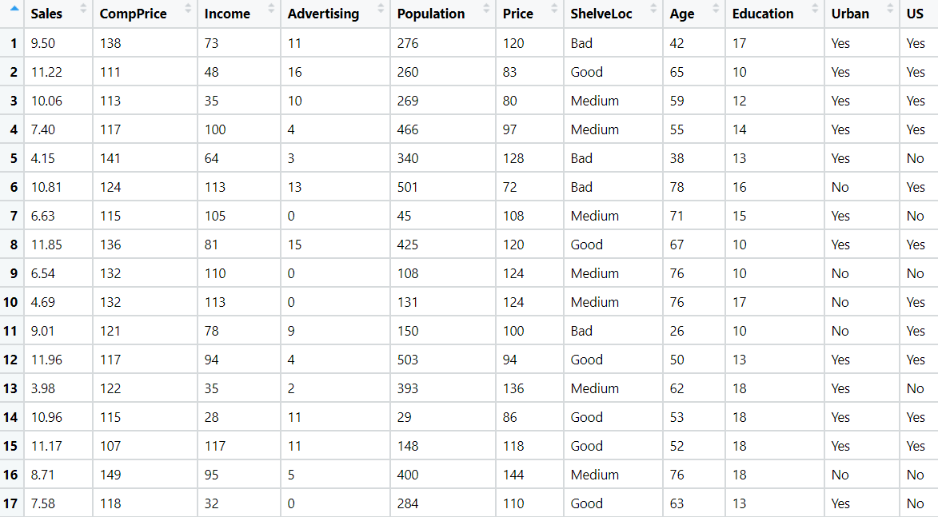

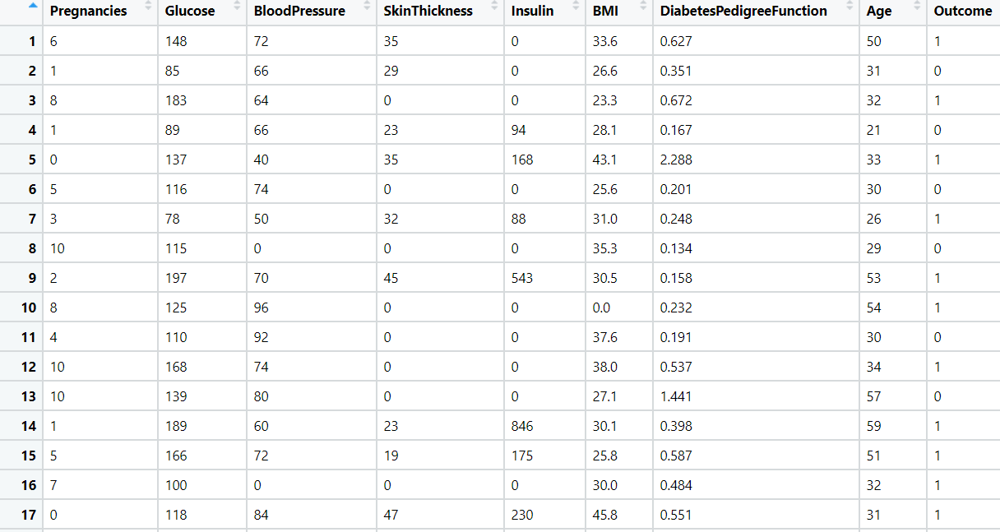

1. Divide the diabetes data into train and test datasets and build a Random Forest and Decision Tree model with Outcome as the output variable.
2. Build a Decision Tree & Random Forest model on the fraud data. Treat those who have taxable_income <= 30000 as Risky and others as Good (discretize the taxable income column).

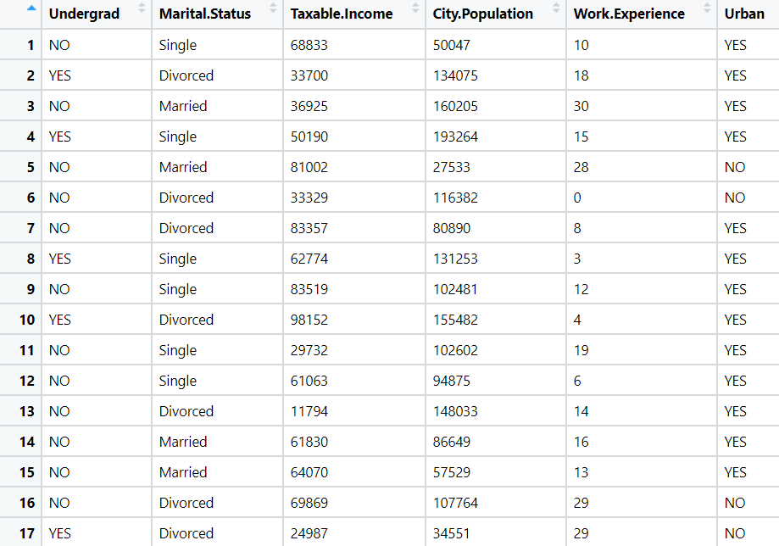

1. In the recruitment domain, HR faces the challenge of predicting if the candidate is faking their salary or not. For example, a candidate claims to have 5 years of experience and earns 70,000 per month working as a regional manager. The candidate expects more money than his previous CTC. We need a way to verify their claims (is 70,000 a month working as a regional manager with an experience of 5 years a genuine claim or does he/she make less than that?) Build a Decision Tree and Random Forest model with monthly income as the target variable.

